Ng new input-output-demo –no-standalone

Scss

N

Ng g c parent

Ng g c child

Parent.component.html

<div class="container">

    <h1>Parent Component</h1>

</div>

Child.component.ts

import { Input ,Output,EventEmitter} from '@angular/core';

export class ChildComponent {

@Input() parentText!:string;

//@Input('parent-text') parentText!:string;

}

Child.component.html

<div class="container bgcolor">

    <h1>Child Component</h1>

    <h3> Parent  Component Says {{parentText}} </h3>

</div>

How to pass value from parent component to child component

parent.component.ts

import { Component } from '@angular/core';

@Component({

  selector: 'app-parent',

  templateUrl: './parent.component.html',

  styleUrl: './parent.component.scss'

})

export class ParentComponent {

parentInputText=" Hello From Parent ";

}

PARENT.COMPONENT.HTML

<div class="container bgcolor">

    <h1>Parent Component</h1>

    <app-child [parentText]="parentInputText"></app-child>

</div>

Child.component.ts

import { Component } from '@angular/core';

import { Input ,Output,EventEmitter} from '@angular/core';

@Component({

  selector: 'app-child',

  templateUrl: './child.component.html',

  styleUrl: './child.component.scss'

})

export class ChildComponent {

//@Input() parentText!:string;

@Input('parent-text') parentText!:string;

}

Parent.component.ts

import { Component } from '@angular/core';

@Component({

  selector: 'app-parent',

  templateUrl: './parent.component.html',

  styleUrl: './parent.component.scss'

})

export class ParentComponent {

parentInputText=" Hello From Parent ";

}

Parent.component.html

<div class="container bgcolor">

    <h1>Parent Component</h1>

    <app-child [parent-text]="parentInputText"></app-child>

</div>

Child.component.html

<div class="container bgcolor">

    <h1>Child Component</h1>

    <h3> Parent  Component Says {{parentText}} </h3>

</div>

Parent.component.html

<div class="container bgcolor">

    <h1>Parent Component</h1>

    <input type="text" (keyup)="sendText($event)">

    <app-child [parent-text]="parentInputText" ></app-child>

</div>

Parent.component.ts

import { Component } from '@angular/core';

@Component({

  selector: 'app-parent',

  templateUrl: './parent.component.html',

  styleUrl: './parent.component.scss'

})

export class ParentComponent {

parentInputText=" Hello From Parent ";

sendText(event:any)

{

  this.parentInputText=event.target.value;

}

}

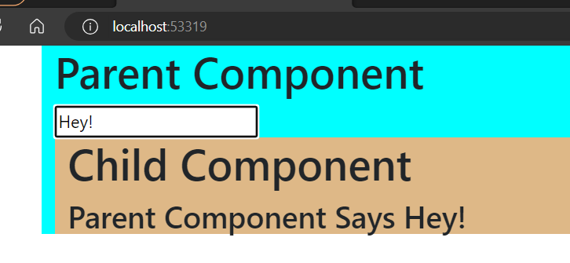

Passing value(or) data from child to parent using @Output and EventEmitter